WHAT IS ETHICS?
Ethics can be described as a way of critically looking at issues that includes:
- Deciding what we should do (what decisions are right or acceptable)
- Explaining why we should do it (justifying our decision using ethical principles)
- Describing how we should do it (the method or manner of our response)
Definition paraphrased from Dr. Barbara Secker, University of Toronto Joint Centre for Bioethics.

WHAT IS AN ETHICAL ISSUE?
If you answer yes to one or more of the following questions you may be facing an ethical issue:
- Am I trying to determine the right course of action?
- Am I asking a “should” question?
- Are values and beliefs involved?
- Am I feeling uncomfortable?

WHO IS RESPONSIBLE FOR ETHICS IN AN ORGANIZATION?
Much like the accountability for quality or patient safety, everyone has a role to play in ensuring the ethical delivery of healthcare, from the point of care to the boardroom. Ethical principles and values should be incorporated into the way that decisions are made and care is delivered every day.

ETHICS IN OUR ORGANIZATION
Renfrew Victoria Hospital recognizes that, during delivery of service to patients and residents, situations may arise where we may not be sure how we can best support each other. Sometimes these instances can lead to conflict among service providers, patients, residents, their families, or substitute decision- makers (SDMs) about an appropriate course of action or non-action. When faced with these challenging situations, anyone needing support can reach out to our ethics consultation service.
The ethics consultation service is available to all service providers, patients, residents, their families, and SDMs. The service is provided in partnership with the Champlain Centre for Health Care Ethics (CCHCE). An Ethicist from the CCHCE is available to support individuals navigating ethical dilemmas and can provide context conscious input. Ethics consults can be held anonymously, in a private one on one setting, or as part of a larger group setting as is appropriate for the matter at hand. In addition to the ethics consultation service, RVH has an established ethics committee that provides ongoing support to the organization in several ways.

ETHICS COMMITTEE
The purpose of the Ethics Committee is to support and promote sound ethical practice and to act as a resource for staff, patients and patient’s families in issues related to ethics. The function of the Committee is:
- Educate the committee, staff, patients and patient families on ethics, rights and how to do ethical thinking.
- Provide input into the establishment of organizational policies . The committee may also assist in developing policies as the need arises.
- Promote patient centered care and raise the consciousness of patient rights and the need for shared decision making across the organization.
- To act as a resource for staff, patients and patients’ families in issues related to ethics.

ETHICS FRAMEWORKS
RVH uses two complementary ethical decision-making frameworks — the IDEA Framework for clinical ethics issues and Accountability for Reasonableness (A4R) for organizational and system-level decisions.
Because clinical and organizational ethics problems are fundamentally different in scope, a single framework cannot adequately support both. Clinical cases often focus on the needs, values, and wishes of an individual patient and family, while organizational questions require a holistic and transparent processes for making decisions that affect members of staff and the community that interact with RVH. Using two frameworks ensures that ethics support is both person-centred and system-aware.

IDEA Framework
IDEA is well-suited for bedside and patient-care situations. It helps teams clarify the ethical question and assess relevant values and principles so teams can move toward a practical course of action. IDEA is a four step framework where each letter of the name represents one step in the framework, see below the IDEA framework in greater detail:

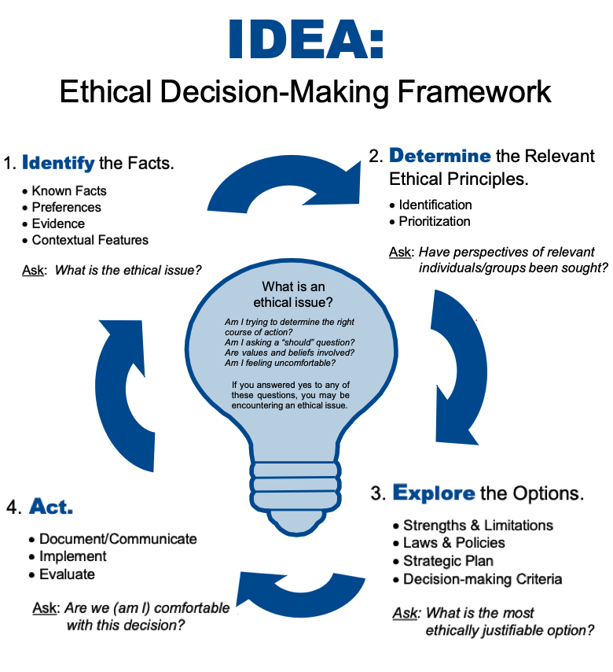

ACCOUNTABILITY FOR REASONABLENESS (A4R) FRAMEWORK
A4R is designed for organizational decision-making where fairness and transparency are essential. It ensures that decisions about policies, resource allocation, or any other systems level issues meet five key conditions: relevance, publicity, appeals/revision, enforcement, and empowerment.
Together, IDEA and A4R allow RVH to respond at both the individual and system level, Ensuring that decisions are grounded in compassion, fairness, and accountability regardless of the context.
To make a case consultation request, please contact Ali Ladak, Regional Ethicist at 613-722-7000 x10248 or by email at alladak@toh.ca
